RENT MANAGEMENT SYSTEM
@CREATIVITY THINK (9483175986/7019689991)

ABSTRACT:
The Rent Management System is a web application designed to streamline rent collection, tenant management, and landlord communication. Users can register, add rental properties, track payment histories, send and receive messages, and access interactive dashboards for monitoring rent status. Administrators can manage tenant profiles, handle payments, moderate communication, and analyze rent collections through analytics dashboards. The backend, implemented with Django and Django Rest Framework, ensures secure data handling, authentication, and business logic, while the frontend uses React, Recharts, and Axios to provide responsive dashboards and visual reports. The system enhances efficiency, transparency, and accountability in rental management..

INTRODUCTION OF THE PROJECT:
Managing rental properties and tenant communications can be cumbersome without a centralized system. The Rent Management System addresses this by providing a web platform for tenants and landlords to manage payments, communication, and rental history efficiently. Users can track rent, view dashboards, and communicate directly, while administrators can oversee tenant profiles, payments, and analytics. Built with Django and Django Rest Framework on the backend and React, Recharts, and Axios on the frontend, the system delivers a secure, intuitive, and visually informative platform for rental management..

PROJECT OBJECTIVES:

• Enable tenants to register and add rental property details
• Track rent payments and maintain payment history
• Facilitate secure messaging between tenants and landlords
• Provide dashboards for rent tracking and reporting
• Allow administrators to manage tenants and rental properties
• Review analytics for rent collections and property management
• Enhance transparency and accountability in rental management

PROBLEM OF THE STATEMENT:
Rent collection and tenant management are often inefficient when handled manually or through disjointed systems. Tenants may miss payments or have difficulty communicating with landlords, while landlords face challenges tracking payments, sending reminders, and maintaining records. Administrators need centralized oversight of properties, tenants, and financial performance. The Rent Management System addresses these issues by providing a web-based platform for managing payments, tenant communication, and analytics dashboards, ensuring efficiency, transparency, and accountability..

MOTIVATION OF THE PROJECT:
• Simplify rent collection and tenant tracking
• Provide real-time dashboards for payment and property analytics
• Enhance communication between tenants and landlords
• Reduce manual errors and missed payments
• Enable administrators to monitor rental performance efficiently

BLOCK DAIGRAM OF PROJECT:

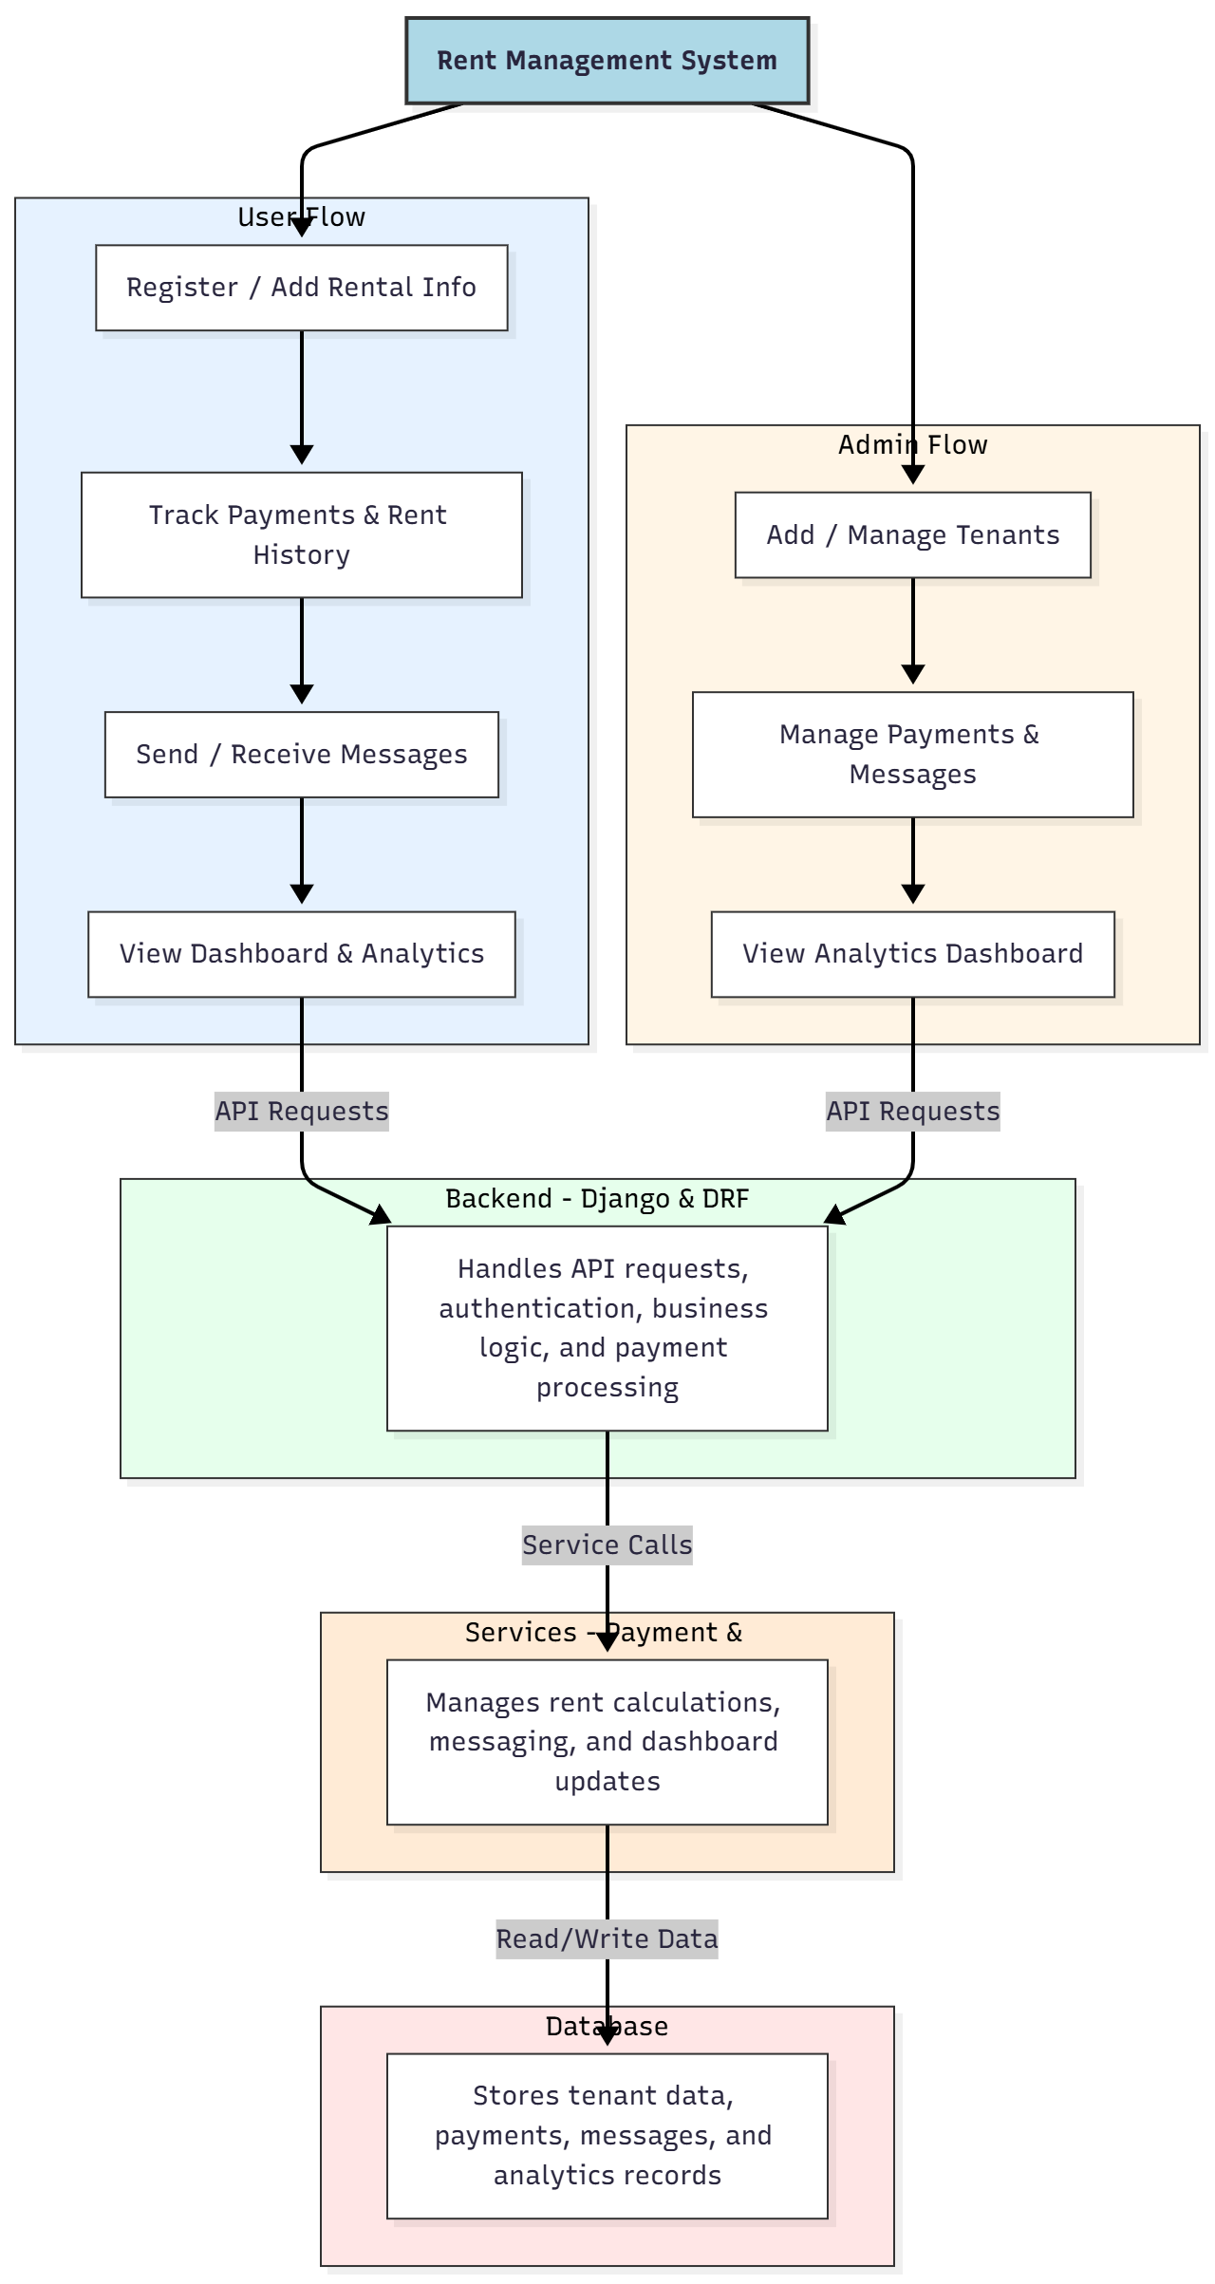

WORKING OF THE PROJECT:
Users browse the e-book catalog, purchase or download selected books, rate and review content, and manage their wishlist with interactive dashboards. The backend handles authentication, transaction processing, and business logic, while services manage PDF invoice generation and dashboard updates. Administrators manage the book catalog, orders, and user reviews, and monitor analytics dashboards to make data-driven decisions. This system ensures a secure, user-friendly, and efficient online e-book platform for both users and administrators..

SOFTWARE REQUIREMENT:
- Backend:
  - Python 3.x
  - Django
  - Django REST Framework
  - SQLite/PostgreSQL
- Frontend:
  - Node.js and npm
  - React.js
  - Axios
- Development Tools:
  - Visual Studio Code
  - Postman (for testing APIs)
  - Git/GitHub (for version control)
- Server/Deployment (Optional):
  - Gunicorn, Nginx, or Heroku/AWS for hosting

ADVANTAGES OF THE PROJECT:

• Seamless online e-book browsing and purchasing
• Downloadable and printable e-books via PDF
• User reviews and rating management
• Wishlist management for user convenience
• Administrative control over catalog, orders, and reviews
• Interactive dashboards for analytics
• Secure transaction management
• Web-based, cross-platform accessibility

APPLICATIONS OF THE PROJECT:
• Online e-book sales platforms
• Educational content distribution
• Digital publishing houses
• Student and library access to e-books
• Authors’ self-publishing management
• Tracking and managing user engagement
• Analytics-driven content strategy
• Integration with online reading or learning platforms

REFERENCES:

- Django REST Framework Documentation — Django Software Foundation. Django Documentation. Available: https://docs.djangoproject.com/
- Django REST Framework. DRF Documentation. Available: https://www.django-rest-framework.org/
- React. React Official Documentation. Available: https://reactjs.org/docs/getting-started.html
- Redux. Redux Documentation. Available: https://redux.js.org/introduction/getting-started
- PostgreSQL Global Development Group. PostgreSQL Documentation. Available: https://www.postgresql.org/docs/
- MySQL. MySQL Reference Manual. Available: https://dev.mysql.com/doc/
- Git. Git Documentation. Available: https://git-scm.com/doc
- Node.js. Node.js Documentation. Available: https://nodejs.org/en/docs/
- Axios. Axios Documentation. Available: https://axios-http.com/docs/intro
- Socket.io Documentation – https://socket.io/docs/

